SEATWORK
^{(Prelim)}
^{NAME: Pedutem, Lou Kristel R.}
^{COURSE/SECTION:}
^{Instructions:}
Insert all the screenshots in each of the questions. Update your “Prelim” repo with a commit details of “SW Prelim - <FULLNAME> <DATE>”. Submit your GITHUB Account Name thru email (alvinsarragaalon@hotmail.com) with a subject format of “CPE 406 SW Prelim - <FULLNAME> <DATE>”
Question 1
If I execute the expression z <- 12 in R, what is the class of the object 'z' as determined by the `class()' function?
Answer:
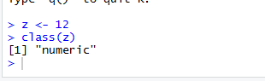

Question 2
What is the class of the object defined by z <- c(12, FALSE)?
Answer:
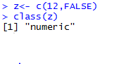

Question 3
If I have two vectors m <- c(10,13, 15, 33) and n <- c(13, 22, 88, 110), what is produced by the expression rbind(m, n)?
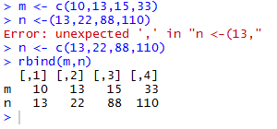

Question 4
Suppose I have a list defined as z <- list(22, "a", "c", FALSE). What does z[[2]] give me?
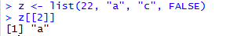

Question 5
Suppose I have a vector z <- 10:40 and a vector y <- 3. What is produced by the expression z + y?
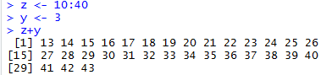

Question 6
Suppose I have a vector x <- c(117, 114, 14, 15, 113, 112, 110) and I want to set all elements of this vector that are greater than 100 to be equal to 14. What R code achieves this?
Answer:
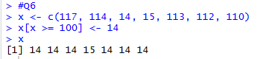

Question 7
In the dataset provided for this Seatwork, what are the column names of the dataset?
Answer:
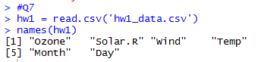

Question 8
Extract the first 12 rows of the data frame and print them to the console. What does the output look like?
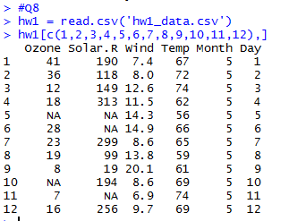

Question 9
How many observations (i.e. rows) are in this data frame?
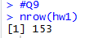

Question 10
Extract the last 8 rows of the data frame and print them to the console. What does the output look like?
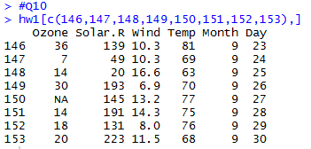

Question 11
What is the value of Wind in the 112th row? Temp in the 42th row? Solar.R in the 82th row?
Answer:
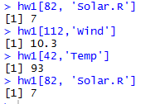

Question 12
How many total missing values are in the columns of this data frame? For Ozone? For Solar.R? For Wind? For Temp?
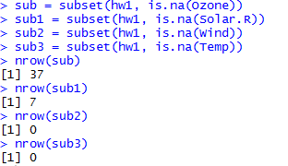

Question
What is the mean for each of the Ozone, Wind, and Temp column in this dataset? Exclude missing values (coded as NA) from this calculation.
Answer:
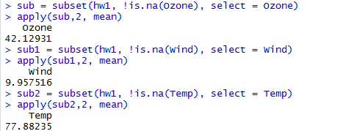

Question 14
Extract the subset of rows of the data frame where Ozone v s are above 26 and Temp values are above 80. What is the mean of Solar.R in this subset?
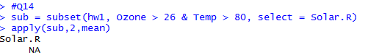

Question 15
What is the mean of "Temp" when "Month" is equal to 8 or 6?
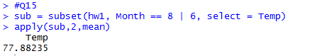

Question 16
What was the maximum ozone value in each of the month (i.e. Month = 5)?
